NAM TRUNG VIET ENVIRONMENT TECHNOLOGY CO., LTD
Address: 88 - 90 Street 3, KDC HimLam, Ward Tho, Thu Duc Dist., HCMC.
Tel: 083.731.2244 - 0915871636 Fax: 083.731.2244
Web: www.namtrungvietenvi.com, www.demvisinh.vn, www.ntvco.vn
Email: namtrungviet.envi@gmail.com
Ho Chi Minh City, October 25, 2018

MBBR PRICE QUOTATION
Dear: Dear Customer

Np | PRODUCT NAME | TECHNICAL SPECIFICATIONS | AMOUNT | UNIT PRICE (VND) | USD | VAT  10% (USD) | TOTAL (USD)
01 | MBBR:PE05  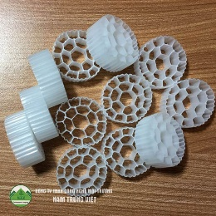 | + Size: diameter x height: 25x10 mm  + Surface ares:500 - 750 m2/m3.  + Tensity:0.95-1.05g/cm3  + material: Plastic HDPE.  + Origin: Nam Trung Viet  + 1m3 ≈ 100 kg | 1kg | 65.000 | 2,8 | 0,28 | 3,08
02 | MBBR: PE03  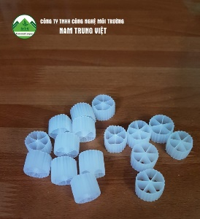 | + Size: diameter x height :15x10 mm  + Surface ares: ≥ 750– 900 m2/m3.  + Tensity:0.95-1.05g/cm3  + material: Plastic HDPE.  + 1m3 ≈ 100 kg  + Origin: Nam Trung Viet | 1kg | 65.000 | 2,8 | 0,28 | 3,08
03 | MBBR: PE03  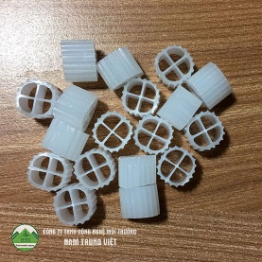 | Size: diameter x height: 11x7mm  + Surface ares: 750 -900 m2/m3.  Tensity:0.95-1.05g/cm3  Material: Plastic HDPE  Origin: Nam Trung Viet | 1kg | 65.000 | 2,8 | 0,28 | 3,08
04 | MBBR: PE08  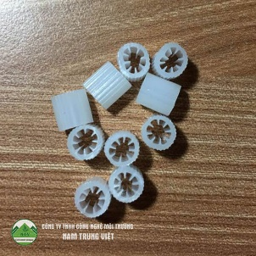 | + Size: diameter x height: 7x10 mm  + Surface ares: ≥ 850 – 1000 m2/m3.  Tensity:0.95-1.05g/cm3  + Material: Plastic HDPE  + 1m3 ≈ 120 kg  Origin: Nam Trung Viet | 1kg | 85.000 | 3,7 | 0,37 | 3,08
05 | MBBR: PE09  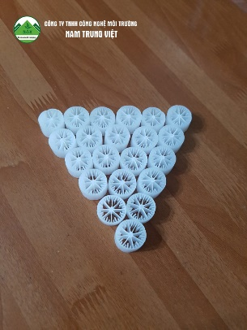 | Size: diameter x height: 15x10 mm  + Surface ares: ≥ 850 - 1000 m2/m3.  Tensity:0.95-1.05g/cm3  + Material: Plastic HDPE  + 1m3 ≈ 100 kg  Origin: Nam Trung Viet | 1kg | 70.000 | 3 | 0,3 | 3,08

* Note : - 1USD = 23.290 VND
- This is a sale in the city
- The above prices include VAT 10%
- Not included transportation to the province
- Method of payment: Cash or transfer

We sincerely thank you and look forward to receiving business cooperation with you soon

CERTIFICATE OF ORDER NAM TRUNG VIET ENVIRONMENT TECHNOLOGY CO., LTD
Day 03/ 11/2018 PPeople quote

NGUYEN THI HUYEN

